A Recipe For:

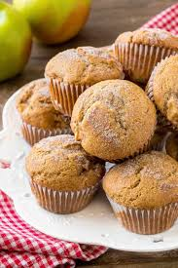 

# Apple Cinnamon Muffins

**From the Kitchen of:** Mom

**Servings:** 9-10

**Prep Time: 1**0 min **Bake Time:** 30 Min. **Bake Temp:** 350

**Ingredients:**

* ½ cup coconut flour
* ½ c tapioca flour
* ½ cup coconut sugar
* ½ tsp baking soda
* ½ Tbsp cinnamon
* Pinch of salt
* 1 apple, cored and diced (pink lady apple)
* ¾ cup cinnamon applesauce
* 3 eggs, whisked
* 1 tsp vanilla
* 1 tsp lemon juice
* 2 Tbsp coconut oil, melted

1. Preheat oven to 350
2. In a large bowl, whisk together coconut flour, tapioca flour, baking soda, cinnamon and apple.
3. Add the rest of the ingredients and mix well until combined.
4. Use an ice cream scoop to scoop the mixture into 10 muffin tins. Bake for 30 minutes.